Link King Soopers Loyalty Cards to
Mount St. Francis – 12228 Community Rewards Account

Once loyalty cards are linked to the Councils account, anyone using them to shop at King Soopers, Kroger, or City Market will help credit the Knights toward future rewards.

Here is how to make the link:
- Access King Soopers Community Rewards page.
NOTE:If you do not have an existing King Soopers web account, go to Pg 3 of this document to create an account.
- Sign in to your account.
- Search for our Council. (12228)
- Click Enroll.

The following (pg 1 & 2) is offered as a more detailed visual guide to the above steps.

- Click on this link to access the community rewards page:
https://www.kingsoopers.com/i/community/community-rewards

- Sign in – Enter your account email and password.
(Requires KingSoopers.com web account <see pg 3 to create.>)

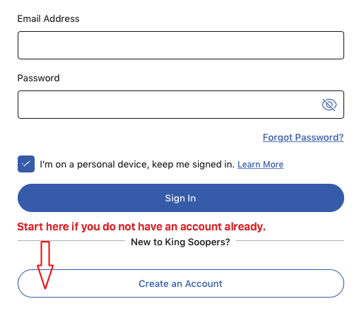

(Continue to next page.)

- Search for our Council. Click the link in section 2, step 2
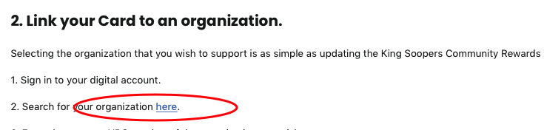
In the next screen, enter the number 12228 and click search.

- Our Mount St. Francis information will appear. Select: Enroll

That’s it. Many thanks for your support to the Knights!

If you have any questions about the program, or difficulty linking your card please reach out to us at this email and we will be happy to assist you: ksoopers@saintfranciskofc.org

How to Create a King Soopers Web Account.

Overview: Other than linking your Loyalty Car, a web account allows you to review purchases, fuel rewards, Pharmacy interactions, find digital coupons, and learn of other shopping bargains available from King Soopers.

These instructions will walk through the process of creating a new account on the King Soopers website. Let’s begin:
- Open the KingSoopers.com webpage and look to the right side of the banner across the tip. Point to the “Sign In” item and a small menu will appear. In that menu, select:
“Create an account”. Example below.
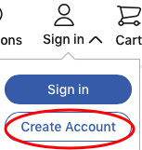

- On the following “Create your Account” screen, enter your name, email address, and password you want for your account.
- In the next section, enter your Sooper Card number or Alternate ID.
  - Note: Enter here what you use at the store checkout.
    - If you scan the card itself while at the register – enter that in this box.
    - If you key in your phone number (Alternate ID), or tell it to the clerk, enter your number.
- Next, are check boxes you may / may not want to ‘uncheck’ concerning email promotions, coupons and advertisements. Terms and conditions must be selected to create an account.
- Now click the “Create Account” button and return to the 1st page of this document, step #1, to continue with linking your Loyalty Card to the Knights.

If you have any difficulty creating an account please reach out to us at this email and we will work with you to address the problem: ksoopers@saintfranciskofc.org

